**SPRINT-3**

|  |  |
| --- | --- |
| **Date** | 19 NOVEMBER 2022 |
| **Team ID** | PNT2022TMID36291 |
| **Project Name** | SMART SOLUTIONS FOR RAILWAYS |

**PROCEDURE:**

Step1: Develop a python script to scan the QR code

Step2: Connect the python code to IBM Cloudant using the credentials

Step3: Run the program

**PYTHON SCRIPT TO SCAN QR CODE:**

import cv2 import numpy as np import time import pyzbar.pyzbar as pyzbar from pyzbar.pyzbar import decode from ibmcloudant.cloudant_v1 import CloudantV1 from ibmcloudant import CouchDbSessionAuthenticator from ibm_cloud_sdk_core.authenticators import BasicAuthenticator

authenticator = BasicAuthenticator('apikey-v2-125rwcp4ifi6zz2ly1cq0kakyjn98du2ysgc72h53lzi', 'af693938842290ec2c254461754447b5') service =

CloudantV1(authenticator=authenticator)

service.set_service_url('https://apikey-v2-

125rwcp4ifi6zz2ly1cq0kakyjn98du2ysgc72h53lzi:af693938842290ec2c254461754447b5@82d8749943954f46-a190-6a186bee5051-bluemix.cloudantnosqldb.appdomain.cloud')

cap= cv2.VideoCapture(0) font = cv2.FONT_HERSHEY_PLAIN while

True:

_, frame = cap.read() decodedObjects = pyzbar.decode(frame) for obj in decodedObjects: #print ("Data", obj.data) a=obj.data.decode('UTF-8') cv2.putText(frame, "Ticket", (50,

50), font, 2, (255, 0, 0), 3)

#print (a)

try:

response = service.get_document(db='booking',doc_id = a).get_result() print(response) time.sleep(5) except Exception as e:

print("NOT A VALID TICKER") time.sleep(5)

cv2.imshow("Frame",frame) if cv2.waitKey(1) & 0xFF ==ord('q'):

break

cap.release() cv2.destroyAllWindows()

client.disconnect()

**PYTHON CODE OUTPUT:**

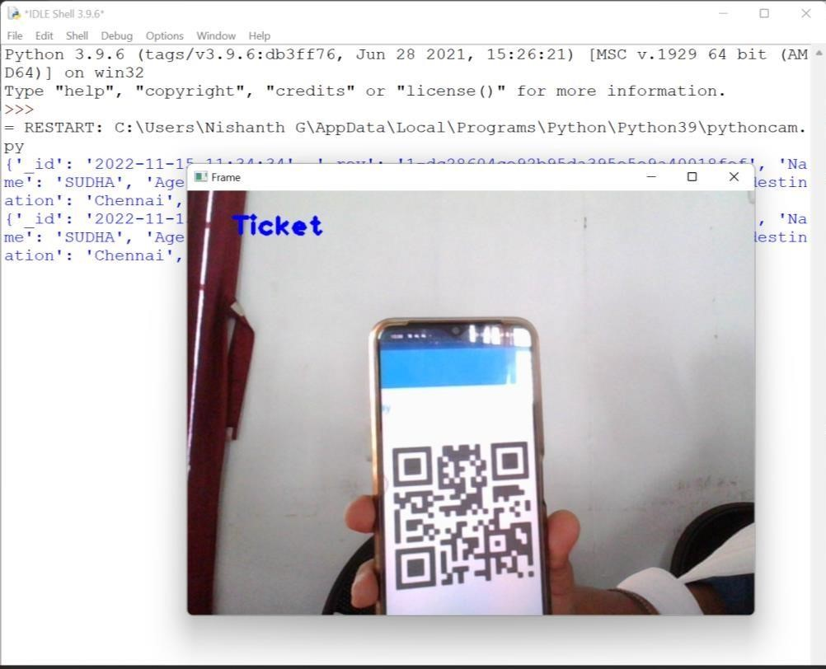

**QR CODE DETAILS:**

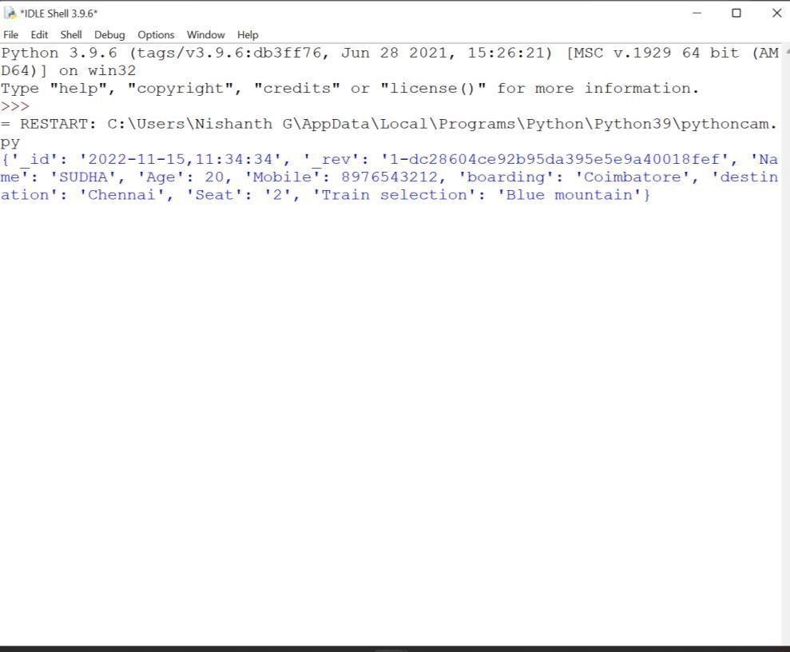

**DATA STORED IN CLOUDANT:**

